|  |  |  |  |  |
| --- | --- | --- | --- | --- |
| Job Title: | Individual Giving Officer | | | |
| Organisational Level | Fundraiser |  | |  |
| Hours: | 37.5  The post holder will be required to undertake commitments outside normal working hours, for example, but not limited to, supporting individuals at fundraising events and attending networking opportunities | Status: | | Permanent |
| Accountable to: | Head of Fundraising &Communication | Responsible to: | | Fundraising Manager |
| Remuneration:  Per annum | £26,000 - £28,000 DOE | Responsible for: | | N/A |
| Location: | Office (minimum 3 days/week) & Homeworking available | | | |
| Date produced: | 16/05/2022 | Date for review: | 16/05/2023 | |

**Main purpose of job:**

The Individual Giving Officer works with the Fundraising Manager to deliver our individual giving program to maximise income from individual donors. With the support of the fundraising team, the post holder will work on both donor recruitment and retention activities, across several different income streams, including Regular Giving, and legacies and be championed to meet an income target of £200,000 in income in the first year. You will support the delivery of a calendar of fundraising campaigns and activities across digital and traditional channels, including direct mail, face to face, social media and email. The position requires someone with a can-do attitude who is both creative and analytical. You will have a passion for excellence in supporter care, and a strong team ethic in working across the Fundraising team and charity as a whole.

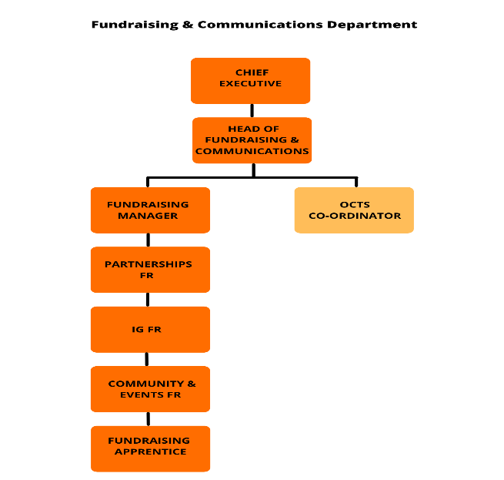**Organisational Structure:**

**Main Areas of Responsibility:**

* You will work closely with the Fundraising Manager to develop and implement the Individual Giving strategy to deliver an income target of £200,000 in the first year.
* You will deliver individual giving fundraising campaigns to recruit and retain individual donors across a range of offline and digital channels, including direct mail, face to face, email and social media.
* You will develop creative, inspiring content, which is fundamental in gaining new donors and retaining existing supporters
* Explore and test new ways of donor recruitment and uplifts in donations
* Working with the Fundraising Manager to develop individual giving plans and budgets
* Working with the Fundraising Team to draft and deliver inspiring creative and content for individual giving campaigns
* Help plan and manage all processes, including the coordination of resources, external and internal
* Use our CRM system to plan, execute and evaluate supporter journeys and donor stewardship activities to maximise donor retention and lifetime value
* Use data segmentation and creative targeting techniques to maximise the effectiveness of appeals
* Put in place appropriate thanking and acknowledgment processes for all individual giving campaigns.
* Keep abreast of UK fundraising trends and best practice, including the regulatory environment and share updates with colleagues
* Attend and support on the day delivery of HO fundraising events as appropriate.
* Work with the Fundraising Manager to develop our legacy proposition and to deliver legacy marketing campaigns and communications to warm supporters
* With the support of the Fundraising Manager, manage a series of ‘legacy events’ to generate new legacy supporters.
* Stay well informed about news and emerging issues relating to the homelessness and housing, as well as fundraising
* Maintain a confidential, sensitive and discrete approach to personal, sensitive and organisational information
* Support the Fundraising Manager to manage a range of external suppliers and agencies to ensure individual giving campaigns and activities are delivered to schedule and budget

**Team-wide responsibilities:**

Homeless Oxfordshire strives to be effective, appropriately challenge people and systems, inspire clients, our partners, and each other. We are responsive to need and compassionate. Above all we are brave and will not give up on people that society may have left behind.

**Key working relationships:**

* Head of Fundraising and Communications
* Fundraising Manager & Fundraising T Team
* Support Services Team
* External partners media, donors and supporters

**Safeguarding statement:**

Homeless Oxfordshire is committed to safeguarding all vulnerable adults, children and young people that come into contact with our services. We believe that all vulnerable adults, children and young people have an equal right to protection from abuse, regardless of their age, race, religion, ability, gender, language, background or sexual identity and consider the wellbeing of the vulnerable adult, child or young person is paramount.

We will take every reasonable step to ensure that vulnerable adults, children and young people are protected where our staff and other colleagues are involved in the delivery of our work. All suspicions and allegations of abuse will be taken seriously and responded to swiftly and appropriately.

We expect everyone (staff, board, associates, volunteers and anyone working on behalf of the Company) to have read, understood and adhere to this policy and related procedures.

## Person Specification:

|  |  |  |  |
| --- | --- | --- | --- |
| **Factors** | **Essential** | **Desirable** | **Recruitment Selection Method**  **(A**pplication**, I**nterview**, As**sessment**)** |
| **Knowledge, Experience, Qualifications, Professional Memberships & Training** | * Ability to meet and exceed individual income targets and manage expenditure accordingly to deliver a strong ROI on all activity * Ability to use a prospecting income pipeline, forecasting and reforecasting income whilst identifying any risk and mitigating accordingly * Plan, execute and evaluate supporter journeys and donor stewardship activities to maximise donor retention and lifetime value * Monitor campaign performance and report against target, highlighting any shortfall * Develop our legacy proposition and deliver legacy marketing campaigns and communications to warm supporters * Create a program of communications to regular supporters thanking them and where appropriate asking for an increase in gift. * Identifying and cultivating relationships to secure long term funding partnerships * The ability to persuade and influence key individuals at all levels, * The ability to research and acquire new potential funding opportunities | * An understanding of the homeless sector * Drivers Licence and access to a vehicle | A, I, As |
| **Communication, Engagement & Relationships** | * Ability to deal with information in a confidential manner and respond with sensitivity Confident and engaging interpersonal skills with the ability to network, influence and build relationships at all levels. * Excellent written and verbal communication skills including report writing, public speaking and presentations * Clear and persuasive facilitation and negotiation skills. * IT literate with knowledge of Microsoft packages. |  | A, I, As |
| **Team Skills** | * Thrives on working with others is motivated by working closely with other people, building and managing relationships and meeting new people. * Excellent at motivating others and building resilience in the team. * Thrives in a fast-paced environment, with a 'can do' attitude. * Enthusiasm, energy and willingness to meet challenging demands and work to deadlines. * Commitment to the Values and Objectives of Homeless Oxfordshire * Excited by and passionate about delivering impact for people experiencing homelessness. |  | A, I, As |
| **Analytical, Problem Solving & Judgement Skills** | * Able to identify and resolve risk management issues according to policy/protocol * Recognises priorities when problem solving and identifies deviations from the normal pattern and can refer these where required for resolution * Ability to analyse data and information, engage stakeholders and weigh up options to make clear decisions. * Demonstratable experience of working successfully within income and expenditure budgets * Understanding of the context in which you work, the needs of others and able to connect people and projects so that the sum of the parts is greater than the individual elements. * Proactive and forward-thinking approach to problem solving. |  | A, I, As |
| **Planning & Organisational Skills** | * Excellent organisational and time management skills with the ability to multitask * Ability to cope with pressure * Able to methodically plan, manage, monitor, advise and review risks and issues and provide resolution * Ability to organise, plan and prioritise on own initiative, including when under pressure and meeting deadlines * Produce timely and informative reports * Manage the flow of process and practice * Proactively participate in annual reviews for self and for others |  | A, I, As |
| **Standards & Compliance** | * Up to date and thorough knowledge of the principles, practice and legislation relating to fundraising, campaigning and communications in a charity setting. * Able to operate competently regarding managing data and information in accordance with the Data Protection Act (DPA) (2018) and the General Data Protection regulations (GDPR). |  | A, I, As |
| **Equality, Diversity & Inclusivity** | * Ability to work in accordance with equal opportunity policies/procedures and promote the equality and diversity agenda of the organisation. |  | I,As |
| **Personal / Professional Development** | * Commitment to developing skills required to progress in role * Commitment to appraisal and annual review process with manager |  | I,As |

*This job description is a broad reflection of current duties, but it is not exhaustive. It will be reviewed on no less than an annual basis to reflect priorities and developments during the on-going appraisal and performance review process and any organisational change arising.*

**Best Practice Recruitment**

**Equality & Diversity**

The organisation is committed to achieving equality of opportunity for all employees and for those who access services. You must work in accordance with equal opportunity policies/procedures and promote the equality and diversity agenda of the organisation.

**Health & Safety**

The organisation recognises its duties under the Health and Safety at Work Act (1974) to ensure, as far as it is reasonably practical, the Health, Safety and Welfare at Work of all its employees and, in addition, the business of the organisation shall be conducted so as to ensure that all individuals having access to organisational premises and facilities are not exposed to risk to their health and safety. All employees under contract will be expected to comply with all appropriate Health and Safety policies and ensure all statutory and mandatory training is up to date.

**Risk Management**

All employees will always follow risk management policies and procedures. All employees are personally responsible for risk management issues in respect of yourself and colleagues. If you identify a potential hazard you should report it to Health and Safety Coordinator at once using the organisational incident reporting process. If in doubt you should speak to your manager for guidance.

All employees have a responsibility to report accidents or incidents promptly and when requested, to co-operate with any investigation undertaken. All employees must use the safety equipment provided and report any defects to their manager. You must attend risk management training as directed by your manager.

If you are a manager or have line management responsibilities for employees, a department or area of work, you are responsible for the risk management issues in that area. In conjunction with risk management you will ensure that there is an annual risk management audit in your area, risks are identified on the local risk register and that where necessary, an action plan eradicating risks is drawn up and implemented.

**Policies and Procedures**

Employees are expected to follow organisational policies, procedures, and guidance as well as professional standards and guidelines. Copies of policies can be accessed via the BreatheHR system and shared drive. The organisation operates a policy which promotes a smoke free environment.

**Appraisal and Personal Development**

The organisation is committed to lifelong learning for all employees and has put in place an appraisal and development infrastructure.

All employees have a responsibility to participate in an annual appraisal with their line manager and to identify performance standards for the post. As part of the appraisal process employees have a joint responsibility with their line manager to identify any learning development needs to meet the agreed performance standards.

**Information Governance**

It is a contractual requirement for the post holder to ensure that as a minimum they acquire the necessary skills to implement good practice in all matters relating to information governance and in particular data which can be attributed to an individual. The job holder must adhere to information governance policies and procedures including the Data Protection Act (2018).

Managers have a responsibility to ensure that their employees are equipped with the necessary tools to use in the implementation of information governance.

**Equal Opportunities**

The organisation is committed to respect for others, equality of opportunity and diversity in the workplace. All managers and employees must know what is expected of them and are responsible for ensuring that this is delivered in practice in their day to day working lives. The organisation will not tolerate any forms of bullying or harassment in the workplace.

|  |  |  |  |  |  |
| --- | --- | --- | --- | --- | --- |
| **Signed:** |  | **Line Manager Name:** |  | **Date:** | Click or tap to enter a date. |
| **Signed:** |  | **Employee Name:** |  | **Date:** | Click or tap to enter a date. |

